INTRODUCTION TO PROJECT

**Objective:**

Develop and implement mobile based attendance system. The need of the project is to take attendance and keep track of the attendance in a mobile device for easy and proper evaluation of attendance. Create an web application providing a consistent user interface to interact with system

The objective of the project is to create a web based attendance maintenance system where the faculty member can mark the attendance on his android mobile which is updated in the server via GPRS. The application reduces manual effort in entering the attendance details in various log books and creating reports is many formats. The details once entered are sent to the server where the reports can be generated as per the requirement. The application communicates with the remote server and executes database queries to update the records.

**Introduction:**

Attendance management system is a software developed for daily student attendance in schools, collages and institutes. If facilitates to access the attendance information of a particular student in a particular class. The information is sorted by the operators, which will be provided by the teacher for a particular class. This system will also help in evaluating attendance eligibility criteria of a student.

**Overview of the project:**

This system will manages Attendance of our college students And Also Notify the students parents when he will bunk the classes ....

SYSTEM STUDY

**Existing system :-**

**Limitation of existing system :**

Not user friendly: The existing system is not user friendly because everything has to be done manually. Requires lot of effort to both shopkeeper and customer.

**Proposed system:**

The main modules involved in this system are:

1. Attendance Details
2. Message information to student parents
3. Staff Details.
4. Leave Manageing.

**Module wise description:**

**Attendance Details**

Modules is used to check the Attendance Details of student. For this the user should give the correct name of the student

The different types of user are

1. Admin
2. Student
3. Lectures

**Message information to student parents;-**

If the student gets less Attendance, then the message will sent to his/her parents immediately.

All information about event is send before two days to each students and parents and also to collage lectures.

**Staff Details.**

Using this application students and parents can also able to access details of faculty

**Modules:-**

All the above mentioned data are stored in the back end and can be retrieved as reports with filtering options. The following of the reports can be taken from this system

1. Class Bunk Notification to Parents.
2. Access attendance details of students.

**Leave Manageing:-**.

Our system will also manages the leave of students... When want to make leave some days college .In that case Leave Will Be managed.

**SYSTEM REQUIREMENTS**

**Hardware And Software Requirements**

**Section Configuration**

Client – Minimum Estimated Requirements

**Hardware**

Processor : Intel Pentium 4 Processor 2.0 Ghz

Ram : 256 Mb

Hard Disk : 40 Gb

**Software**

Operating System : Windows 7/Linux

Development Tools

Front – End Tools : html , css , bootsrap 4.

Language : php

Back End Tools : mysql.

**FLATFORM USED**

**PHP AND MYSQL**

**HYPER TEXT PREPROCESSOR (PHP):-**

Hyper Text Preprocessor (PHP) lets you separate the dynamic part of your pages from the static HTML. We simply write the regular HTML in the normal manner, using whatever web-page-building tools you normally use. We then enclose the code for the c parts in special tags, most of which start with “<?php” and end with “?>”.

We normally give your file a. php extension, and typically install it in any ace you could place a normal web page. Although what you write often looks more a regular HTML file than a servlet. Behind the scenes, the php page just gets converted to a normal servlet, with the static html simply being printed to the output stream associated with the servlet’s service method.

This is normally done the first time the page is requested and developers can simply request the page themselves when first installing it if they want to be sure that the first real user doesn’t get a momentary delay when the php page is translated to the servlet and the servlet is compiled nd loaded many web browsers let you define aliases that so that a URL that appears to reference an html file really points to a servlet or PHP page.

**MYSQL:-**

MYSQL is the world’s most used open source relational Database management system(RDBMS) that runs a server providing multi-user access to a number of databases. MYSQL is a popular choice of database for use in web application, and is a central component of the widely used LAMP open source web application software stack(and others ‘AMP tacks). LAMP is an acronym for “Linux, Apache, MySql, Perl/PHP/Python.” Free-software-open source projects that require a full-featured database management system often use MySql.

MYSQL workbench is available in two editions, the regular free and open source Community edition which may be downloaded from the MySql website, and the proprietary standard edition which extends and improves the feature set of the community edition. Third party proprietary and free graphical administration applications (or “front ends”) are available that integrate with MySql and anable users to work with database structure and data visually.

**FRONT END AND BACK END**

**FRONT END**

**HTML:-**

**HTML** means HyperText Markup Language. HTML is a method of describing the format of the documents which allows them tto be viewed on computer screens. HTML documents are displayed by web browsers, programs which can navigate across networks and display a wide variety of types of information. HTML pages can be developed to be simple text or to be complex multimedia extravaganzas containing sound, moving images, virtual reality, and java applets.

The global publishing format of the internet is HTML. It allows authors to use not only text but also format that text with heading. Lists, and tables, and to include still images, video, and sound within text. Readers can be access pages of information from any where in the world at the click of a mouse-button. Information can be downloaded to the reader’s own PC or workstation. HTML pages can also be used for entering data and as the front-end for commercial transactions.

**Features of HTML:-**

* It is a not a programming language.
* It is not data description language.
* It is simple to understand and implement.
* HTML constructs a very easy to comprehend, and can be used effectively by anybody.
* The methodology used by HTML to mark up information is independent of its representation on a particular hardware or software architecture.
* HTML syntax is a world wide standard.

**Hyper Text Preprocessor (PHP):-**

**Hyper text pre-processor (php)** lets you separate the dynamic part of your pages from the static HTML. We simply write the regular HTML in the normal manner, using whatever web-page-building tools you normally use, we then enclose the code for the c part in special tags, most of which start with “<?php” and end with “?>”.

We normally give your file a .php extensions, and typically istall it in any ace you could place a normal web page. Although what you write often looks more a regular HTML file then a servlet, behind the scenes, the PHP page just gets converted to a normal servlet, with the static html simply behind printed to the output string associated with the servlet’s service method.

This is normally done the first time the page is requested, and developers can simply request the page themselves when first installing it if they want to be sure that the first real user doesn’t get a momentary delay when the php page is translated to be a servlet and the servlet is compiled and loaded. Many web servers that you define aliases that so that a URL that appears to a to reference and html file really points to a servlet or php page.

**PORTABILITY:-**

**PHP** is an open-source server side scripting language designed for web development to produce dynamic web pages. It is one of the first developed server-side scripting languages to be embedded into an HTML source document rather then calling an external file to processdata. The code is interpreted by web server with a php processor module which generates the resulting web page. It has also evolved to include a command line interface capability and can be used in standalone graphical applications.

PHP can be deployed on most web servers and also as a standalone shell on almost every operating system and platform free of charge. PHP was a competitor to Microsoft’s active server pages (ASP) server-side script engine and similar languages.

**COMPOSITION:-**

It was mentioned earlier that the php architecture could include reusable PHP components. The architecture also allows for the embedding of a scripting language directly into the php file. The components current supported include sessions and serves. As the default scripting language, php pages use the C programming language, java scripts, html. This means that scripting on the server-side can take advantage of the full set of capabilities that the C programming language offers.

**PROCESSING:-**

A php file is essentially an html document with php scripting or tags. It may have associated components in the form of class or it my not. The use of components is not required.

The php file has a.php extension to identify it to the server as a hyper text pre-processor pages file. Before the page is served, the php syntax is parsed and processed into a servlet on the server-side. The servlet tat is generated, outputs real content in straight html for responding to the customer. Because it is standard html, the dynamically generated responds looks no different to the customer Browser than a static response.

**PHP Scripting Elements:-**

PHP scripting elements let you insert php code into the servlet that will be generated from the current PHP page. There are three forms:

1. Expressions of the form <?php=expression ?> that are evaluated and inserted into the input.
2. Script lets of the form <?php code ?> that are inserted into the servlet’s services method.

**Access modes :-**

**Php** file may be accessed in at least two different ways:

A client request comes directly in to a php page. In this scenario. Suppose the page accessed reusable ”include.php” components that perform particular well - defined computations like accessing a database. The page uses such a beans to generate dynamic content and present it back to the client.

a request comes through a servlet. The servlet generates the dynamic content. To handled the response to the client, the servlet creates a file and stores the dynamic content(sometimes called the result set) the servlet then invokes a php.

Php is best summarized as an embedded server - side web scripting language that provides the developers with the capability to quickly and efficiently built web applications. Php bears a close resemblance, both synatactically and grammarly, to the c programming language although developers haven’t been shy to integrate features from a manipulation of languages including perl, java and c++. Several of these valuable borrowed features include regular expresion, parsing, powerful array handling capabilities, and object oriented methodology and vast database support.

Php can also serve as a valuable tool for creating and managing a dynamic content, embedded directly beside the likes of javascript , stylesheets, wml ( wirless markup language) and many others usefull languages. Providing a hundreds of predefined functions .extensive support is offered for creation and manipulation ,mathematical calculation ,e-commerce and burgeoning technologies such as extensive markup language(xml),open database connectivity(odbc)and macromedia sock ware.

In this project we have implemented three-tire model.commands are sent to a “middle tier” of services.which then send sql statements to the database.

**Advantages of php:-**

* Php can generate dynamic page content
* Php can create,open,read,write and close files on the server
* Php can collect from data
* Php can send and receive cookies
* Php can add,delete,modify data in your database
* Php can restrict users to access some pages on your website
* Php can encrypt data
* Php runs on different platforms(windows,linux,unix,mac os x,etc)
* Php is compatible with almost all servers used today(apache,iis,etc).
* Php has support for a wide range of databases

**How php works?**

Php pages exist in 3 forms or versions:-

* php source code consists of text file with an extension of php and contains a mix of html template code, c language statements and java script
* Directives and actions that describe how to generate a web page to service a particular request.
* Php source code:the jsp container translates the jsp source code into the source code for an equivalent java servlet as needed..

**What is php script?**

* Php script is embedded into html.
* It is browser dependent.
* Php script depends on the web browser to support it.if the browser doesn’t support it,php script code will be ignored.internet explore 3.0 and netscape navigator 2.0 onwards support php script
* It is an interpreted language,loosely typed,object based language.

Why php?

* Php runs on different platforms (windows,linux,unix,mac osx,etc.)
* Php is compatible with almost all servers used today (apache,iis,etc.)
* Php has support for a wide range of databases .
* Php is free. Download it from the official php resource:
* Php is easy to learn and runs efficiently on the server side.

**Client side framework:-**

The client side framework includes the following:

* Web browser
* Html client extension (active x controls and netscape plugging)
* Scripts language (php scripts) php script role in web application development.

**Client side application:-**

Php script has capabilities when working with html tags and java script. For certain cases java script provides a programming backbone with which to develop a application

**Data validation:-**

Php provides the means for basic data validation before it is sent to the server. Whether the values entered are correct or not or whether all the fields in a form are filled out or not can be checker before sending data to web server would response with a message that the data sent to it is incorrect or incomplete. Thus,php ensures data validation and also reduces the network traffic.

**Php database connectivity:**

In an enterprise computing which is largely the black art of managing huge databases? People associated with the enterprise need to be able to use and update the data easily, quickly and securely.

Php database connectivity is a standard sql database access interface providing uniform access to a wide range of relational databases. It also provides a common base on which higher level tools and interfaces can be built.

**Connection:-**

A connection object represents a connection with a database. A connection session includes the sql statements that are executed and the results that are returned over the connection. A single application can have one or more connections with a single database, or it can have connections with many databases.

**Sending statement:-**

Once a connection is established, it is used to pass sql statements to its underlying database. Mysql_query() sends the sql statements. This provides a great deal of flexibility, allowing the use of database-specific statements or even non-sql statements. It requires, however, that the user be responsible making sure that the underlying database can process the sql statement being sent and suffer the consequences if it cannot.

**Session:-**

This is the **http** **session** object associated with the request. Recall that sessions are created automatically, so this variable is bound even if there was no incoming session reference. The one exception is if you use the **session** attribute of the page directive to turn sessions off, in which case attempts to reference the session variable errors at the time the jsp page is translated into a servlet.

Xampp:-

**Access:** create a php web application or mobile application using net beans built and run project, this will automatically launch the wamp as default.

**Viewing web applications:-**

<http://localhost/>

**Directory structure:-**

The typical and default directory hierarchy of a tomcat installation comprises the following:-

* Bin -startup, shutdown and other scripts and executable.
* Common -common classes that cataline and web applications can use.
* Conf -xml files and related dtds to configure tomcat.
* Logs-cataline and application logs.
* Server-classes used only by cataline.
* Shared- classes shared by all web applications.
* Web apps -directory containing the web applications.
* Work-temporary storage for files and directories.

A web application is basically a web site that:-

* “knows who you are”-- it doesn’t just give you static pages, it interact with you.
* Can permanently change data(such as in a database).
* A web application can consist of multiple pieces.
* Static web pages(possibly contening a forms).
* Servlets.
* Php wamp organizes all these parts into a single directory structure for each web application.

**The flow that takes place is :-**

* The user submits an html forms
* Wamp finds the servlet based on the url and the deployment descriptor(web.xml) and passes the request to the servlet
* The servlet computes a response
* Either: the servlet writes and html page containing the response

The servlet forwards the response to the jsp

The php embeds the response in an html page

* Wamp returns the html page to the user

**Status:-**

Wamp is available at the php.net binary Downloads page. The wamp server is based Web Application container that was created to run Servlets and PHP pages in web applications. As part of wamp open source, it has nearly become the industry accepted standard references implementation for both the Servlets and PHP.

Wamp server includes the apache tomcat Apache Tomcat(formerly under the Apache Jakarta Project; Tomcat is now a top level project) is a web container developed at the Apache Software Foundation.

BACKEND:

Overview of MYSQL;-

**MYSQL**

It the world’s most used open source Relational Database Management systems(RDMS) that runs as a server providing multi-user access to a number of databases. MYSQL is a popular choice of database for use in web applications, and is a central component of the widely used LAMP open source web application software stack (and other’ AMP stacks). LAMP is an acronym for “Linux, Apache, MYSQL, Perl/Python.” Free-software-open source projects that require a full-featured databse management system often use MYSQL.

**.** Adminer – a free MySQL Front end written in one PHP script, capable of managing

Multiple databases with many CSS skins available.

**.** DaDaBIK – a customerized CRUD Front-end to MYSQL. Written in PHP. Commercial.

**.** DBEdit – a free front end for MySQL and other databases.

**.** dbForge GUI Tools – a set of tools for database management that includes separate applications for scheme comparison and synchronization, data comparison and synchronization, and building queries.

**.** Heidi SQL – a full featured free front end that runs on Windows, and can connect to local or remote MySQL Servers to manage databases, tables, column structure, and individual data records.

**LibreOffice Base –**

LibreOffice Base allows the creation and management of database preparation of forms and reports that provide and users easy access to data. Like Access, it can be used as a front-end for various database systems, including Access database (JET),

**ODBC data sources and MYSQL SQL.**

* Navicat –a series of proprietary graphical database management applications, developed for windows, Macintosh Linux.
* Open office .org-Open office.org base can be manage MYSQL database if the entire suite is installed. free and open-sources
* php My Admin-a free web based frontend widely installed by web host since it is developed php and is included in the LAMP stack ,MAMP ,XAMP and WAMP software bundle installer.
* SQL Buddy-a free web based frontend developed php.
* Sequal Pro-a free, open source front end for Mac OSX.
* SQL Yog-a free community,-developed UI for MYSQL.

MySQL is written in C and C++.its SQL parser is written in home-brewed .Many programming languages with language specific APIs include libraries for accessing MYSQL database .these include MYSQL Connector/Net for integration with microsoft visual video(language such as C# and VB are most commonely used )and the jdbc driver for java.in addition and odbc interface called my odbc allows additional programming language that support the odbc interface tocommunicate with MYSQL database,such as asp or cold fusion.the HTSQL_URL_based query methd also shifts with a MYSQL adopter ,allow in direct interaction between a MYSQL database and any web client via structured URLs.

**Features:**

* Cross-platform support
* Updatable Views
* Transactions with the DB and Cluster storage Engineers savepoints with Inno DB.

We can import and export the database

**Why MySQL?**

* Free as in Freedom-released with GPL version 2 license (through a different license can be bought from oracle ,see below)
* Cost-free!
* Support-online tutorials, formulas, mailing list (lists.mysqll.com),paid support contracts.
* Speed-one of the fastest database available.
* Functionality-supports most of ANSI SQL commands.
* Ease of use – less need of training/retraining.
* Portability-easily import/export from excel and other database.
* Scalable-useful for both small as well as large database containing billions of records and terabytes of data in hundreds of thousands of tables.
* Permission control-selectively grant or revoke permission to users.

**Limitation:-**

* Like other SQL databases, MySQL does not currently comply with the full SQL standards for some of the implemented functionality, including foreign key references when using some storage engines other than the ‘standard’ InnoDB.
* Triggers are currently limited to one per action/timing, i.e. maximum one after insert and one before insert on the same table. There are no triggers on views.
* MySQL, like most other transaction Relational databases, is strongly limited by hard disk performance. This is especially true in terms of write latency. Given the recent appearance of very affordable consumer grade SATA interface solid-state drives that offer zero mechanical latency, a fivefold speedup over even an eight drive RAID array can be had for a smaller investment.

**SELECT statement**

This statement is used to select certain attributes from table.

Format: SELECT<ATTRIBUTES>FROM<TABLENAME>WHERE CONDITION:

**INSERT statement**

Enables the user to enter data directly into the table.

Format: INSERT INTO TABLENAME(ATTRIBUTE NAMES…)

VALUES (ATTRIBUTE VALUES)

**UPDATE STATEMENT**

Enables to modify the data already stored in the table.

Format; UPDATE TABLENAME

SET COLUMNNAME=VALUE

WHERE CONDITION

**DELETE statement**

Enables you to remove selected row of data from single table.

Format: DELETE FROM TABLENAME

WHERE CONDITION

**Views:**

A View is a personalized presentation of data from one or more tables. View does not contain or store data, but they take data from the tables on which they are based, called base tables. As the tables the views can also be queried, update, inserted and deleted, with some restrictions.

Format: CRETE VIEW VIEWNAME AS

SELECT FIELDS

FROM TABLENAME

WHERE CONDITION

**Indexes**

An index is an optional structure associated to tables that increases the data recovery performance. An index is created for one or more columns of table. After being created, an index is automatically updated and used by ORACLE.

Format: CREATE INDEX INDEXNAME

ONTABLENAME( NAMEOFTHECOLUMN ASC/DESC,..)

**Relational database management system**

In an RDBMS, a database is considered to be a collection of inter related data and programs. The data in database has to be related. The program in perform the role manipulating this data. A database management system is a software that takes care of maintaining the database. It acts as the interface between the database and the user.

A database that is design on relational model of database is called ‘relational data’ and the software that helps maintains those databases is called ‘relational database management system,. In the relational data model the data in a database is an organized in ‘relations’. A relation is synonyms with a ‘table’. A table consist of columns and rows, in which are referred those fields and records in DBMS terms and attributes in are DBMS terms

**Users of an RDBMS:**

* Database designers: these would be the people who analyze the kind of data that is to be stored in the database, and would design the structure of the database.
* Database administrator more popularly called the DBA, this would be a person who monitors operations on a database and ensures that is maintained efficient.
* Application developer: this category of a people takes care of writing programs for accessing the database

End user: entity of data and manipulation of data is taken care of by the end user.

**System Analysis**

**INITIAL STUDY:-**

This involves the investigation of the existing system, which includes a vast level of interviews with the user and the concernesd staff in sufficient depth. This also includes the collection and study of detailed information and litareture regarding the complete existing procedure.

The detailed initial study properly designed and proper outline of the proposed computerized system is prepared. The proposed design is bought against all the known facts and further proposals are made. Various resources including the software, hardware and manpower requirements are decided and are mentioned in report.

**User Objectives:-**

**The system shall:**

* Be user- friendly and shall facilitate smooth functioning of a system.
* Reduce operating costs and saves time.
* Be flexible and adaptable to the existing process.
* Allow some amount of customization.

**Entity Relationship Diagram**

An entity relationship diagram, also called entity relationship model, is a graphical representation of entities and their relationships each other, typically used in computing in regard to the organization of data within databases or information systems.

An relationship diagram represent the schemes rather than the instants. This is more useful because a database scheme changes rarely, whereas the extension changes frequently. In addition, the scheme is usually easier to display than the extension of database.

Element of ER-Diagram:

Entity: An entity can be a person, place, event, or object that is relevant to a given system. For example, a school system may include students, teachers, major courses, subjects, fees and other Subjects. Entities are represented in ER diagrams by a rectangle and named using singular nouns.

Entity

**Weak Entity:-**

A weak entity is an entity that depends on yhe existence of another entity of another entity. In more technical terms it can be defined as an entity that cannot be identified by its own attributes. It uses foreign key combined with its attributed to form the primary key. An entity like order subjects is a good example for this. The order Subjects will be meaningless without an order so depends on the existence of order

.

Weak Entity

**Attribute:-**

An attribute is property , trait, or characteristics of an entity, relationship, or another attribute, For example, the attribute inventory Subject Name is n attribute of the entity inventory Subject.

An entity can have as many attributes as necessary. Meanwhile, attributes can also have their own specific attributes. For example, the attribute “customer ad dress” can have the attributes number, street, city and state. These are called composite attributes. Note that some top level ER diagrams do not show attributes for the sake of simplicity. In those that do, however, attributes are represented by oval shapes.

**Multivalued Attributes**

If an attribute can have more than one value it is called an multivalued attribute. It is important to note that this is different to an attribute having its own attributes. For example a teacher entity can have multiple subject values

**Relationship**

A relationship describes how entities interact. For example, the entity “carpenter” may be related to the entity “table” by the relationship “builds” or “makes”. Relationships are represented by diamond shapes are labeled using verbs.

Relationship

**DFD (Data Flow Diagrams)**

In the traditional S.D.L.C data flow diagrams were generated in the analysis phase and structure charts were used in the design phase. Modern by software experts suggested an amendment to this. According to them instead of drawing two versions of the same concept (one for the end users & another for the Programmers ). Only one format could be designed from being a programmer to being one of the members of the design team. So, even though the end users might require the easy to understand data flow diagrams have thought of as the new basis for the design.

Designing with the Data flow Diagrams involves creating a model of the systems. The entities and Attributes are model, of the states of the system. Processes model the rules of a systems. The stimuli and response are modeled by Data Flows. All these models are combined into one graphic model called a Data flow Diagram.

DFD’s have a notation for each of the system. They also have a notation for representing different levels in hierarchy of detailed used to describe the systems. This notation makes it possible to represent an overall view of a large complex system and a detailed view of a system using the same notation makes it possible to represent an overall view of a large complex system can be isolated into independent sub-system. These work together as a unit to perform a set of processes that must be done together at one time

The Gone & Sarson Notation for the Data Flow Design has been followed for the current documentation. The nomenclature for the Gone & Sarson Notation is discussed next.

**PROCESSES:-**

Processes show what the system does. Each process has one or more inputs and one more outputs. If a processes does not have an output an output then it is considered to a Black Hole. The notation for the process is:

ID

Process Name

**FILE/DATA STORE;-**

A file or data store indicates a respiratory of data. Process can Enter and retrieve Data from each Data store. Each data source has unique name. The notation for the Data store is:

ID

**EXTERNAL ENTITIES:-**

External entities are outside the system but they either supply input data into the system or make use of the system output. They are entities on which the designer has no control. They May be an organization customer or others with which the system interacts. External entities, which supply the data into the system, are sometimes called sinks. The notation for external entity is

External Entity Name

**DATA FLOWS:-**

Data flows model the flow of data in the system. It is indicated by line joining the system components. An arrowhead indicates the direction of data flow and the labels above the line indicates then name of the data-flow. The notation for the Data Flows is:

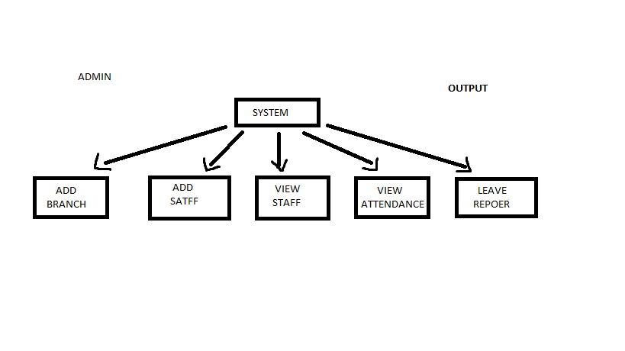**ADMIN DFD:-**

**STUDENT DFD:-**

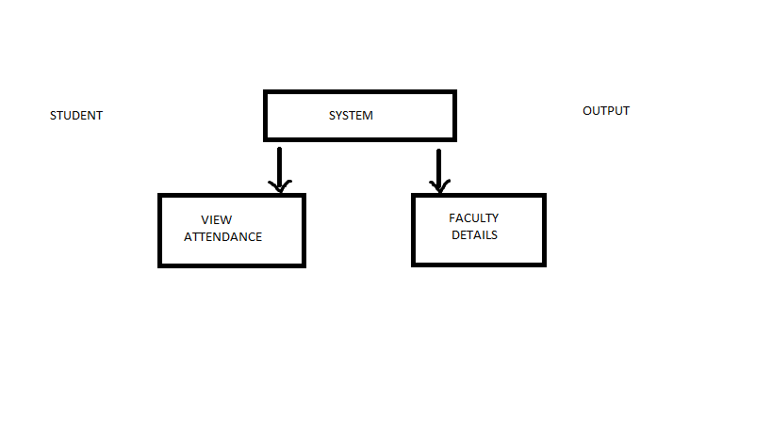

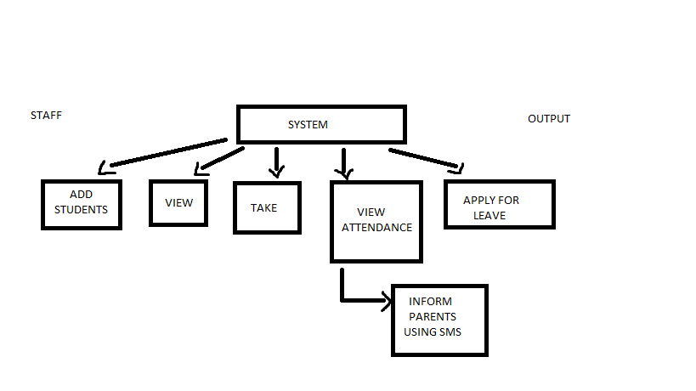**STAFF DFD:-**

**Requirement Specifications :-**

Actual user community participation and their requirement analysis are key to success of any new information system. To carry out this work, identification of users who will actually use the system is foremost. Users at every level were given opportunity to define their goals , objectives and their respective information needs. In addition to this exercise a critical though investigation of present reports and query generated, were carried out to define any other additional requirements that can be useful to the others.

The findings of users and other related of users and other related exercise to access particular user needs are summarized below concisely:

- The System must provide a graphical user interface.

- Redundancy must be reduced at the maximum level.

- Discrepancies should be avoided .

**SYSTEM DESIGN**

**SYSTEM DESIGN :-**

System design provides the understandings and procedural details necessary for implementing the system recommended in the system study. Emphasis in on the translating the Performance requirements into design specifications.

The Design Phase in transition from a user-oriented document (System proposals) to a document oriented to the programmers or database personnel.

System Design goes through two phases of development:

**.** Logical Design.

**.** Physical Design.

A data flow shows the logical flow of the system. For system it describes the input (source), output (destination), database (data stores) and procedures (data flows) all in a format that meets the user’s requirement. When analysis prepares the logical system design. They specify the user needs at a level of detail that virtually determines the information flow into an out the system and thee required data resources. The logical design also specifies input forms and screens layouts.

The activities following logical design are the procedure followed in the physical design e.g., producing programs, software, file and a working system. Design specification instruct the user about what the system should do.

System Design is the first design stage in which the basic approach to solving the problems is selected. During system design, the overall structure and style are decided.

It consist of 2 modules:

Administrator module.

User module.

**DETAILED DESIGN :-**

During detailed design the internal logic of each of the modules specified in the system design is decided.

In system design the focus is on identifying the modules, where, as during detailed design the focus is on designing the logic for each of modules. In words, in system design the attention is on what components are needed, while in detailed design how the components can be implemented in the software. During this phase further of the data structure and algorithm design of each of the module is usually specified in a high-level design description language, which is independent of the target in which the software will eventually be implemented.

Thus a design methodology is systematic to creating a design by application of set of techniques and guidelines

**DATABASE DESIGN :-**

**User Login:**

|  |  |  |  |
| --- | --- | --- | --- |
| **USERNAME** | **Varchar** | **10** | **Primary Key** |
| **PASSWORD** | **Varchar** | **10** |  |

**CODING PAGES:-**

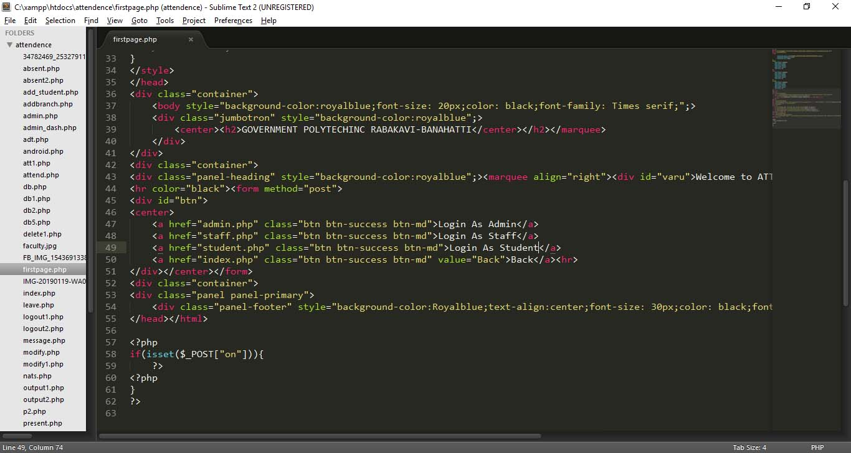

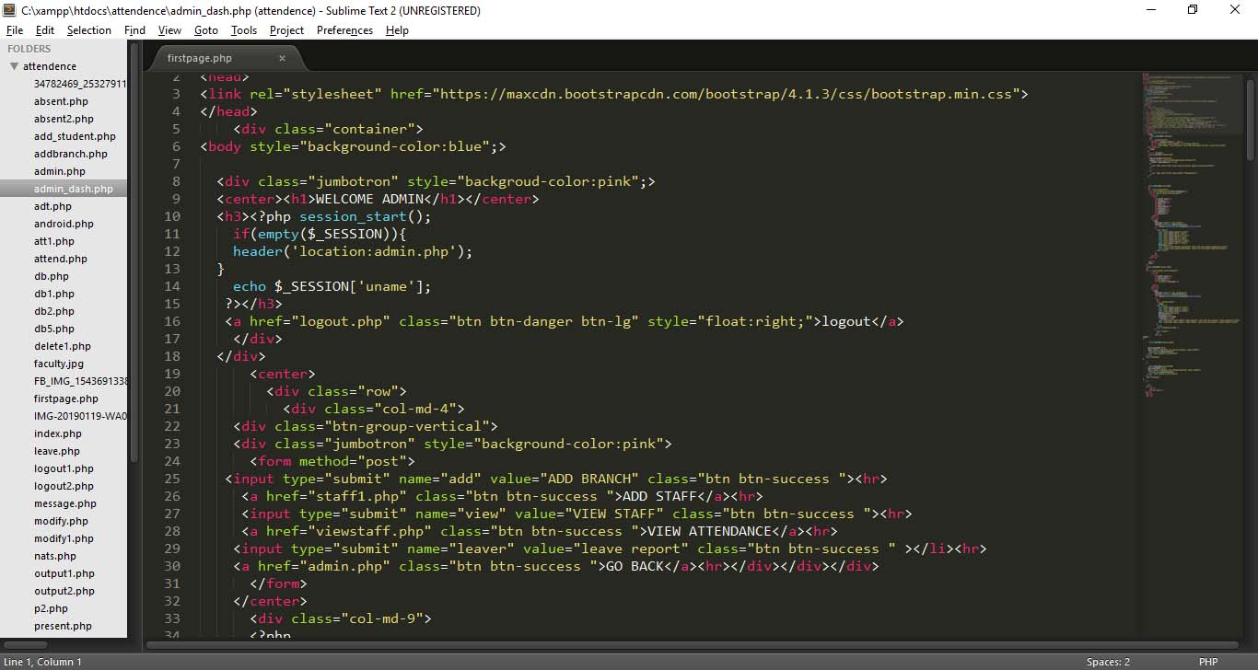

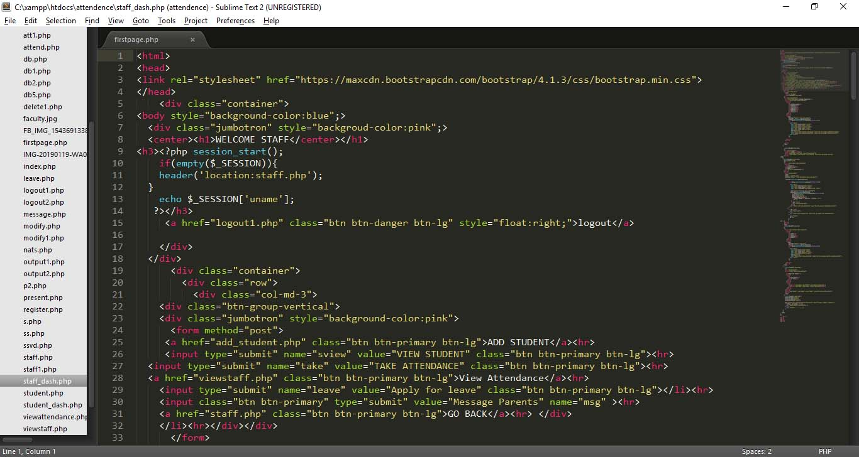

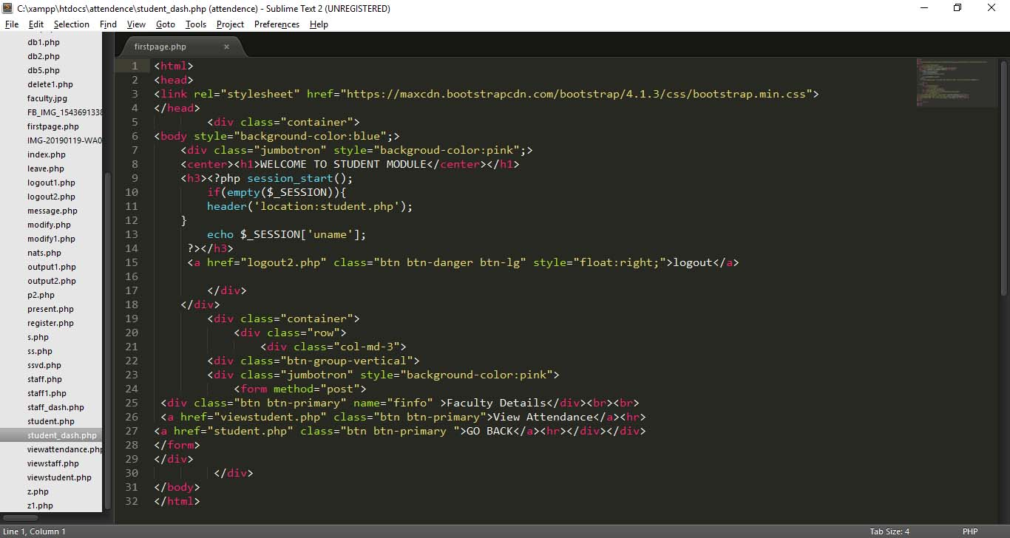

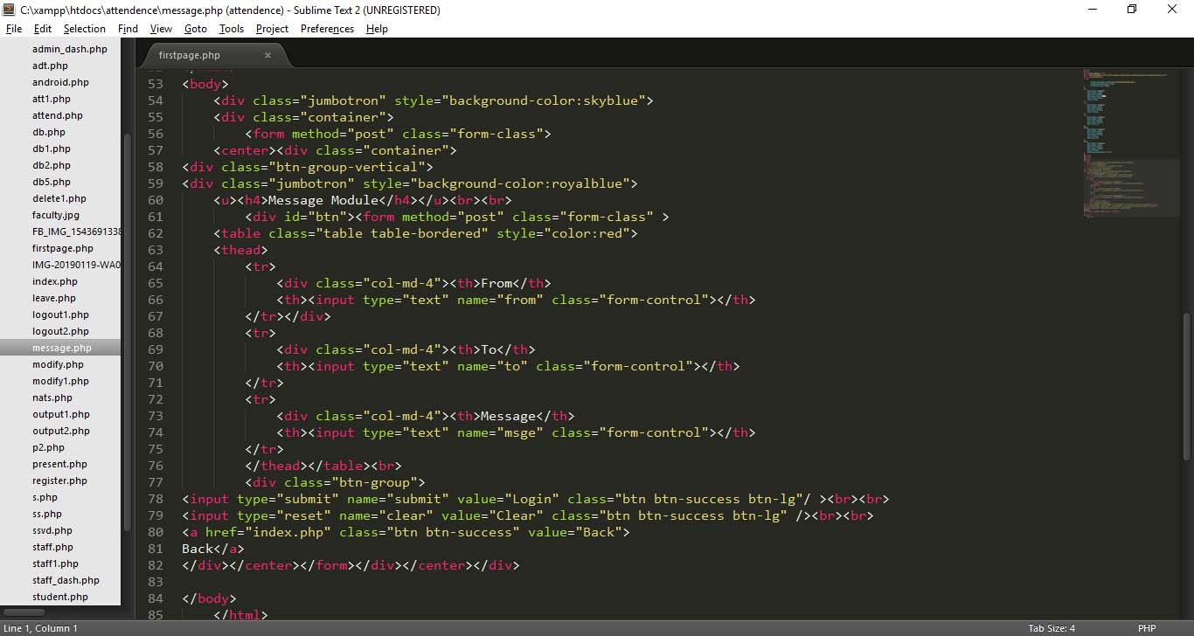

**SCREENSHOTS;-**

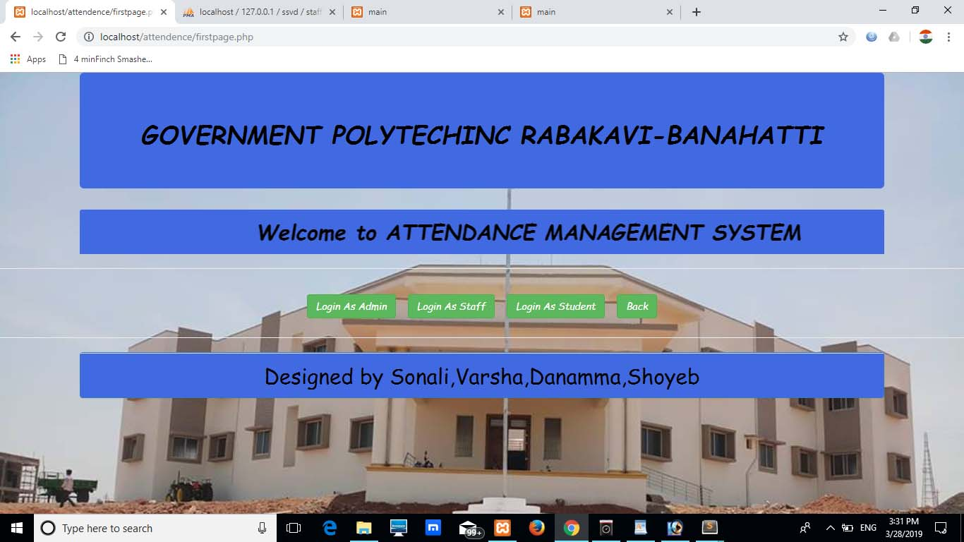**FROUNT PAGE:-**

**LOGIN PAGES:-**

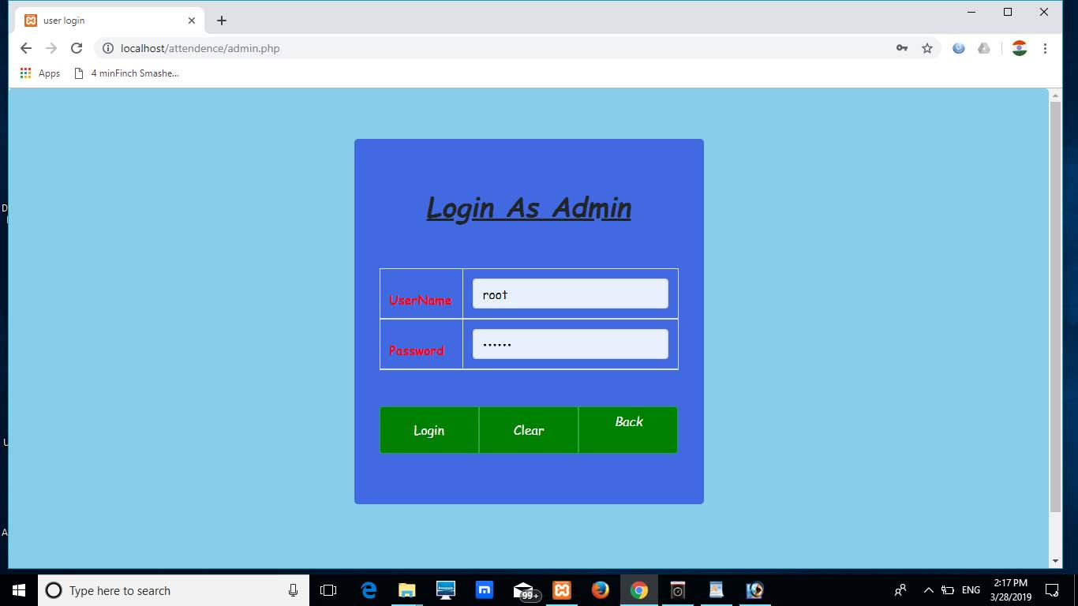

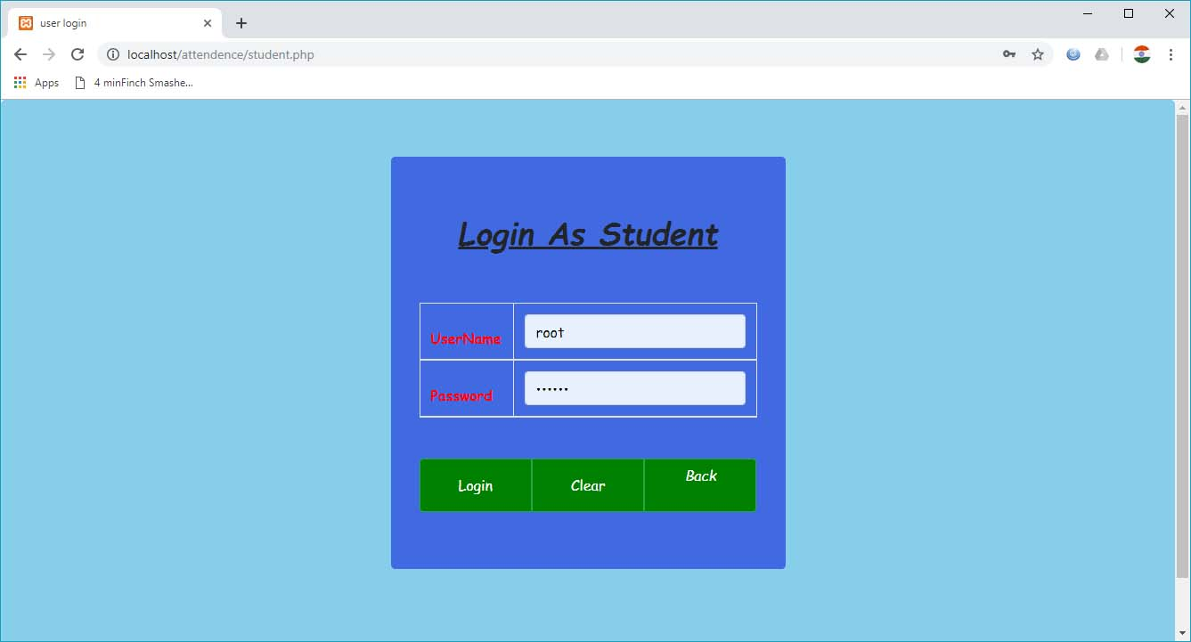

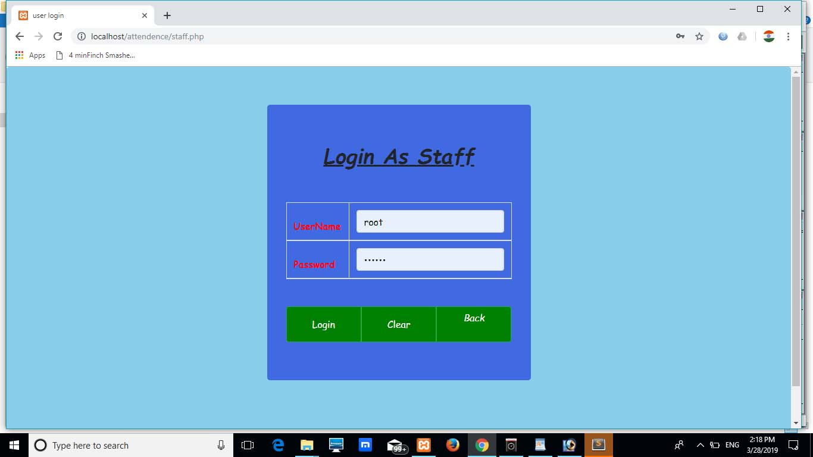

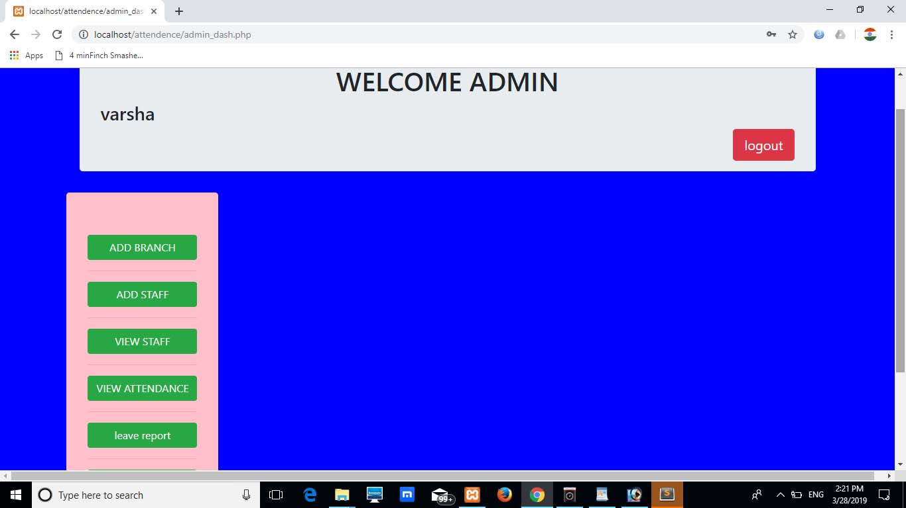**ADMIN_DASHBOARD PAGE:-**

**STAFF DASHBOARD PAGE:-**

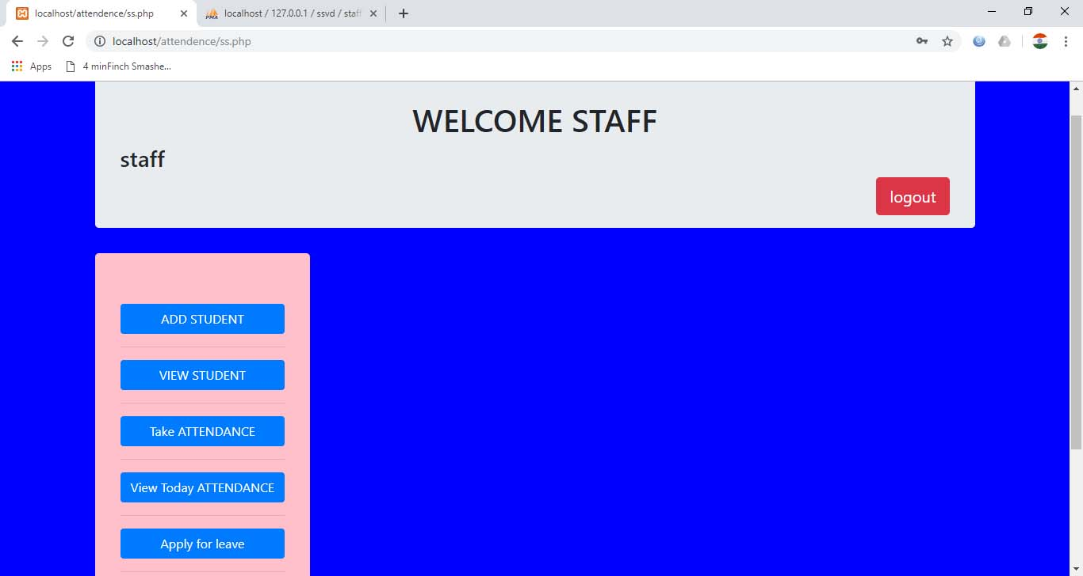

**ADMIN DASHBOARD PAGE:-**

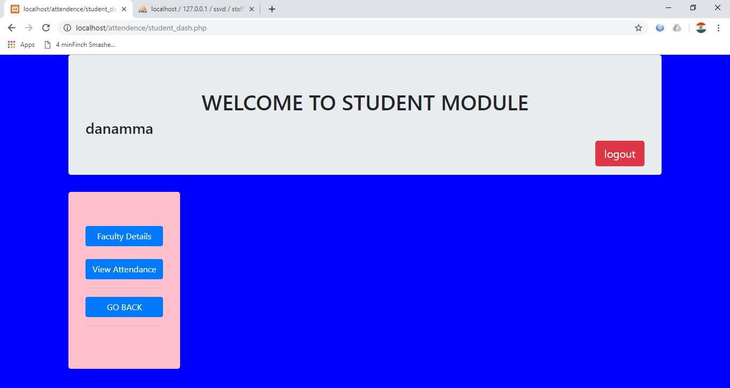

**MESSAGE MODULE:-**

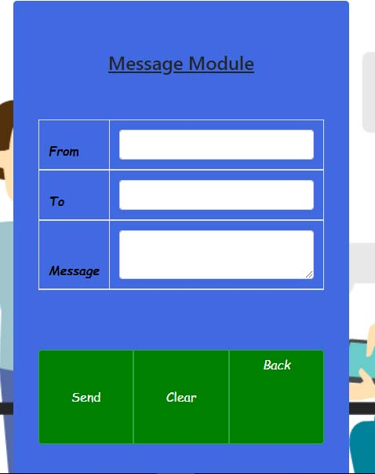

**CONCLUSION**

**Conclusions:-**

The attendance management system is developed using web programming fully meets the objectives of the system which it has been developed the system has reached a steady state where all bugs have been eliminated the system is operated at a high level of efficiency and all the teachers and user associated with the system solves the problem it was intended to solve as requirement specification.

.

**BIBLIOGRAPHY:-**

**GUIDED BY:**

**Shanthamma A.**

**(HOD OF CSE)**

**Websites:-**

<http://php.net.in/j2EE>

<http://php/w3school/Students/js/reference/faqs/index.html>

<http://www.sololearn.com>

<http://www.tutorialspoint.com/bootsrap4>

<http://www.tutorialspoint.com/php>

<http://www.tutorialspoint.com/database(mysql)>

<http://www.tutorialspoint.com/html>

<http://www.tutorialspoint.com/css>